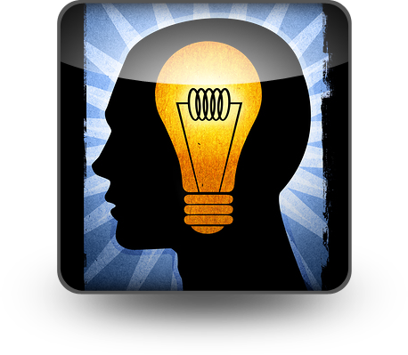

**The Reflective Log**

**Learning Outcome:**  **To engage your thinking & write reflectively about learning as it is happening. Then utilize the idea of *“pause to look behind and then plan ahead”* to capture your thinking while learning advances both the current work and provides a roadmap for the next learning experience.**

As part of your culminating project, you will be keeping a “journal” through posts on your blog. What is a blog, you ask? In simple terms, a blog is a “website”, where you write “stuff” on an ongoing basis. New stuff shows up at the top, so your visitors can read what's new. A blog, unlike a website, allows visitors to comment on your “posts”.

**Create a Blog**

Follow the directions below to create a blog site using **edublog**. Remember, this is online, so make sure you remember internet safety. *(*If you do not have internet access at home you will need to complete the Reflective Log requirements using the document template found on your class Moodle site; ReflectiveLog_document_template. Remember you must upload to the class Moodle site with your name if you are using the document format in order to receive credit.)*

**Posting to your Blog**

Each of your posts should answer the following:

1. **What you did (action plan item from your Culminating Project Proposal)**
2. **What you learned (from completing the action plan item)**
3. **How much time it took (to complete the action plan item)**

You should be posting at the completion of each action plan item from your Culminating Project Proposal AND any other important events or thoughts that occur. Your posts are meant to reflect on a specific part of your action plan in detail. Also, remember you are communicating with an audience, so make sure you check your posts for spelling, grammar and punctuation errors. You want your audience to ***want*** to continue to read, so write to your audience



**Creating & Posting to edublog:**



1. Go to the website <http://edublogs.org/>
2. In the bottom, right corner click
3. This will take you to the screen to create an account.
4. 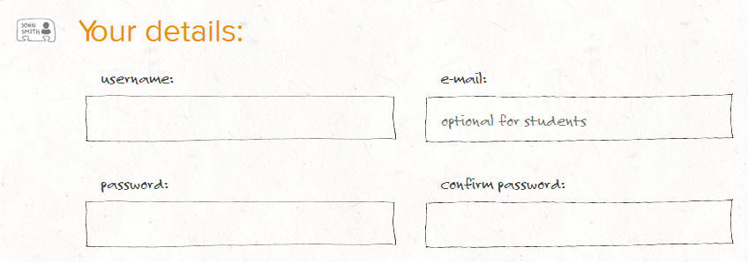Fill in the form to create your account.

**A.**

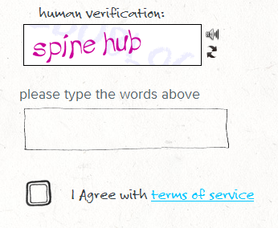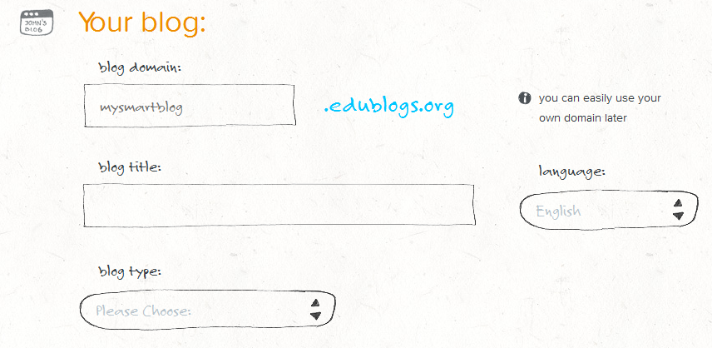

**C.**

**B.**

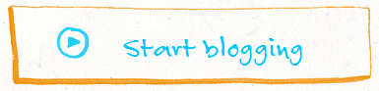

1. Then click **Start Blogging** to begin!

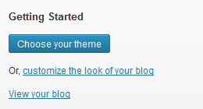

1. When you first start you will be able to **customize** your blog.
2. When you return to the site each time you will need to log in & **write a new blog post**.

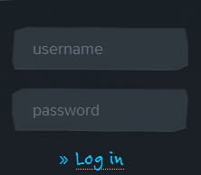

1. When you write each new blog post, be sure to consider the following…
   1. **Through the use of a blog; reflects on what was accomplished and what was learned, to communicate to a broader audience, about the experience at multiple points while completing action items for a project**
      1. Postings provide detailed insight, understanding, and reflective thought about what was learned while completing action items, at multiple points during the project
   2. **Communicate effectively and efficiently in a variety of formats (written, visual, spoken word)**
      1. Blog posts respectfully engage audience
      2. Blog posts are free of grammatical, spelling or punctuation errors
      3. Blog posts use language which have a clear message and is content-specific to topic

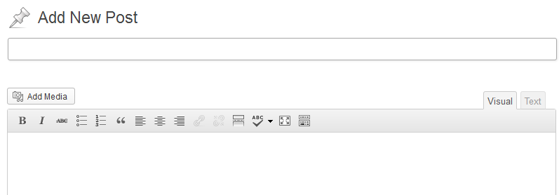

1. 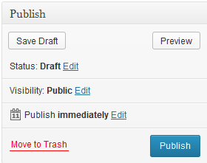When you are finished with your current blog post, click **Publish.**